https://www.jdoodle.com/embed/v0/5TV3
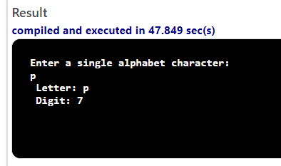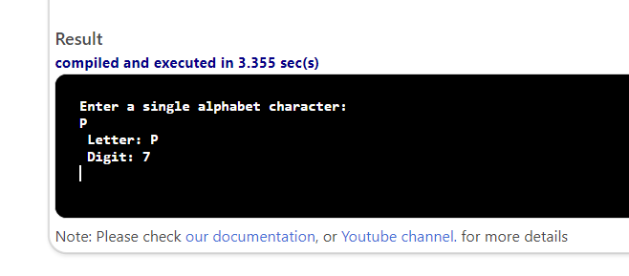

#include <iostream>

using namespace std;

int main()
{
char letter;
int digit;

cout << "Enter a single alphabet character: "<<endl;
cin >> letter;
cout<<endl;
switch (letter)
{
case 'a':
case 'b':
case 'c':
case 'A':
case 'B':
case 'C':
digit = 2;
break;

case 'd':
case 'e':
case 'f':
case 'D':
case 'E':
case 'F':
digit = 3;
break;

case 'g':
case 'h':
case 'i':
case 'G':
case 'H':
case 'I':
digit = 4;
break;

case 'j':
case 'k':
case 'l':
case 'J':
case 'K':
case 'L':
digit = 5;
break;

case 'm':
case 'n':
case 'o':
case 'M':
case 'N':
case 'O':
digit = 6;
break;

case 'p':
case 'q':
case 'r':
case 's':
case 'P':
case 'Q':
case 'R':
case 'S':
digit = 7;
break;

case 't':
case 'u':
case 'v':
case 'T':
case 'U':
case 'V':
digit = 8;
break;

case 'w':
case 'x':
case 'y':
case 'z':
case 'W':
case 'X':
case 'Y':
case 'Z':
digit = 9;
break;

default:
cout << "Invalid input. Please enter a letter." << endl;
digit = -1; // or any other value to indicate an error break;
}
cout << " Letter: " << letter << endl;
cout << " Digit: " << digit << endl;
return 0;

}

